Assignment No. 15
- TITLE : Demonstration of Object Oriented Programming using Java and database through JDBC

- CODE:
1. JDBC Connection
package prac15;
import java.sql.*;
import java.io.*;

public class JdbcConnection {

private static final String USER="jdbc:mysql://localhost:3306/student";
private static final String Root="root";
private static final String pswd="admin";

public static void main(String args[])throws IOException,ClassNotFoundException
{
Class.forName("com.mysql.jdbc.Driver");
try(Connection con=DriverManager.getConnection(USER,Root,pswd))
{
System.out.println("Connected Successfully");

}catch(Exception e)
{
e.printStackTrace();
}
}
}

Output - Connected Successfully

2. Register
package prac15;
import java.sql.*;
import java.util.Scanner;

public class Register {
public static void main(String[] args) {
String url = "jdbc:mysql://localhost:3306/student";
String user = "root";
String password = "admin";

try {
Class.forName("com.mysql.jdbc.Driver");
Connection connection = DriverManager.getConnection(url, user, password);

if (connection != null) {
System.out.println("Connected to the database!");

String createTableSQL = "CREATE TABLE IF NOT EXISTS students (id VARCHAR(50) PRIMARY KEY, name VARCHAR(100), email VARCHAR(100), password VARCHAR(100))";
Statement stmt = connection.createStatement();
stmt.executeUpdate(createTableSQL);
System.out.println("Table 'students' is ready.");

Scanner scanner = new Scanner(System.in);
System.out.print("Enter ID: ");
String id = scanner.nextLine();
System.out.print("Enter Name: ");
String name = scanner.nextLine();
System.out.print("Enter Email: ");
String email = scanner.nextLine();
System.out.print("Enter Password: ");
String pass = scanner.nextLine();

String insertSQL = "INSERT INTO students (id, name, email, password) VALUES (?, ?, ?, ?)";
PreparedStatement pstmt = connection.prepareStatement(insertSQL);
pstmt.setString(1, id);
pstmt.setString(2, name);
pstmt.setString(3, email);
pstmt.setString(4, pass);
pstmt.executeUpdate();

System.out.println("Data inserted successfully!");

scanner.close();
stmt.close();
pstmt.close();
connection.close();
}
} catch (ClassNotFoundException e) {
System.out.println("MySQL JDBC Driver not found!");
e.printStackTrace();
} catch (SQLException e) {
System.out.println("Connection failed!");
e.printStackTrace();
}
}
}

Output -
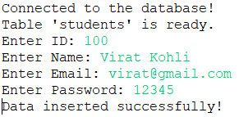

2. Login
package prac15;
import java.sql.*;
import java.util.Scanner;

public class Login {
public static void main(String[] args) {
String url = "jdbc:mysql://localhost:3306/student";
String user = "root";
String password = "admin";

try {
Class.forName("com.mysql.jdbc.Driver");
Connection connection = DriverManager.getConnection(url, user, password);

if (connection != null) {
System.out.println("Connected to the database!");

Scanner scanner = new Scanner(System.in);
System.out.print("Enter ID: ");
String id = scanner.nextLine();
System.out.print("Enter Password: ");
String pass = scanner.nextLine();

String loginSQL = "SELECT * FROM students WHERE id = ? AND password = ?";
PreparedStatement pstmt = connection.prepareStatement(loginSQL);
pstmt.setString(1, id);
pstmt.setString(2, pass);

ResultSet resultSet = pstmt.executeQuery();

if (resultSet.next()) {
String name = resultSet.getString("name");
String email = resultSet.getString("email");
System.out.println("Logged in successfully!");
System.out.println("Welcome, " + name + "!");
System.out.println("Email: " + email);
System.out.println("ID: " + id);
} else {
System.out.println("Invalid ID or password!");
}

scanner.close();
resultSet.close();
pstmt.close();
connection.close();
}
} catch (ClassNotFoundException e) {
System.out.println("MySQL JDBC Driver not found!");
e.printStackTrace();
} catch (SQLException e) {
System.out.println("Connection failed!");
e.printStackTrace();
}
}
}

Output –
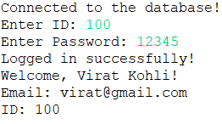

MySQL
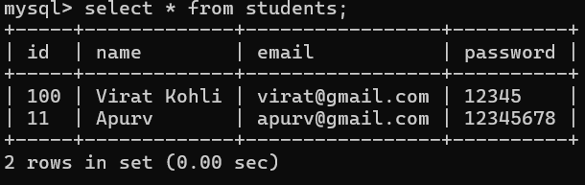

- Conclusion – In this assignment, we have established a connection with MySQL database using a jdbc-driver and implemented a simple user login and register form.

